**2018-2022 Co-Teaching Program**

**2022**

* 2022.12.26 Dr. Jo-Chi Jao invited Professor Cheng-Shie Wuu from Columbia University for international collaborative teaching (In--service master course, online teaching).Topic: Current Status of FLASH Radiation Dosimetry and the Role of 3D Dosimetry.（Department of Medical Imaging and Radiological Sciences）
* 2022.12.19 Dr. Jo-Chi Jao invited Prof. Kwan Hoong Ng from University of Malaya, Malaysia for international collaborative teaching (undergraduate course, online teaching).Topic: Detection and measurement of x-ray and gamma rays.（Department of Medical Imaging and Radiological Sciences）
* 2022.12.12-12.15 Dr. Wanchai Assavalapsakul from Chulalongkorn University, Thailand visited Medical Laboratory Science and Biotechnology, KMU for research collaboration, and collaborative teaching to our graduate students.（Department of Medical Laboratory Science and Biotechnology）
* 2022.11.03 Professor Wang Zhihong of Stanford University gave a speech on "Epidemic Prevention Technology and Epidemic Surveillance and Prevention" on November 3, which was co-organized by the Center for Global Health and Security Research, and Director Yawen Qiu assisted in inviting Professor Wang Zhihong to visit and give a speech.(Department of Public Health)
* 2022.11.02-11.03 To enhance the students’ sensitivity of international health issues, Prof. Betty Ya-Wen Chiu invited Prof. Masamine Jimba from the University of Tokyo, Japan, and the former president of APACPH to deliver two speeches.(Department of Public Health)
  + On November 2nd：Prof. Masamine Jimba gave a lecture entitled "Infectious Disease and Global Health" based on his long-term research and practical experience in global health. His speech provided students with different global views on infectious diseases, which greatly broadened students' international vision.
  + On November 3rd：Prof. Masamine Jimba, as an expert who worked for WHO and Japan International Cooperation Agency (JICA), gave a lecture on "Why I worked for WHO and JICA-a journey of humanitarian aid." Prof. Jimba shared plentiful precious practical experience and career path, including his works in Nepal, Vietnam, Cambodia, Palestine, and Jordan. All participants gave a high appraisal and positive feedback after the lecture.
* 2022.06.06 Shu-Ping Chen, Associate Professor (Department of Occupational Therapy, University of Alberta) and Ying-Chun Chou held an international co-teaching, Topic: The role of occupational therapy in advancing school mental health （Department of Occupational Therapy）
* 2022.05.31 Prof. Cheng-Shie Wuu, Radiation Oncology, Columbia University, NY, USA. Topic: A Review of Clinical Physics in Current Radiotherapy.
* 2022.05.24 Prof. Kwan Hoong Ng, University of Malaya, Malaysia. Lecture title: Abstract writing for thesis and scientific paper (In--service master program, online)
* 2022.05.23 Prof. Kwan Hoong Ng, University of Malaya, Malaysia. Lecture title: Quality assurance program in radiology - overview and progress (Bachelor program, online)
* 2022.05.13 Prof. Kwan Hoong Ng, University of Malaya, Malaysia. Lecture title: Highlights of some technological developments during the COVID-19 Pandemic. (Bachelor program, online)
* 2022.05.02 Prof. Kwan Hoong Ng, University of Malaya, Malaysia. Lecture title: Abstract writing, poster and oral presentation for conference (Master program, online)
* 2022.03.14 Prof. Min-Ying Lydia Su, University of California, Irvine, USA. Topic:  Artificial Intelligence-Based Imaging Analysis for Precision Clinical Management.

**2021**

* 2021.11.11 Professor Mina Samukawa (Faculty of Health Sciences, Hokkaido University) presented her experiences working as IOC’s service team in the Tokyo Olympics 2020 for the elite athletes.
* 2021.06.24-06.25 Associate Professor Liang-Yin Ke invited Professor Gopal K Marathe from Mysore University, India to teach in the International Scholar Collaborative Teaching and present the most updated research findings.（Different glycoforms of alpha-1-acid glycoprotein contribute to its functional alterations in platelets and neutrophils／Effect of acyl and alkyl analogs of platelet-activating factor on inflammatory signaling）
* 2021.01.07 Prof. Kwan Hoong Ng, University of Malaysia, Creativity in scientific research.
* 2021.01.04 Prof. Kwan Hoong Ng, University of Malaysia, How to write and publish a scientific paper.

**2020**

* 2020.11.05 Associate Professor Tsu-Hsin Howe from Department of OT, NYU, USA, visited Department of OT, KMU, and participated collaborative teaching activities.
* 2020.02.07-02.11 IPNFA Instructor Shozo Katsunami held PNF Level Workshop for MSs students and alumni of Department of Physical Therapy.

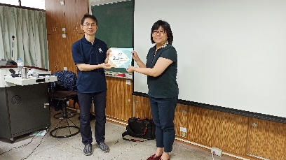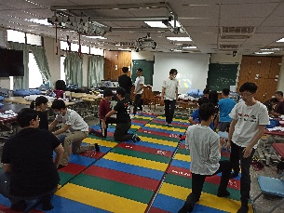

**2019**

* 2019.12.27 The Department of Occupational Therapy have been invited Dr. Sunny Hu from IFE Central Analytical Research Facility, Queensland University of Technology in Australia, make a special speech: “Introduction higher education system in Australia”.
* 2019.12.25-12.27  Dr. Sheng-Fan Wang invited Dr. Wanchai Assavalapsakul from the Department of Microbiology, Chulalongkorn University, Thailand to join the co-teaching and gave some lectures for the graduate students.

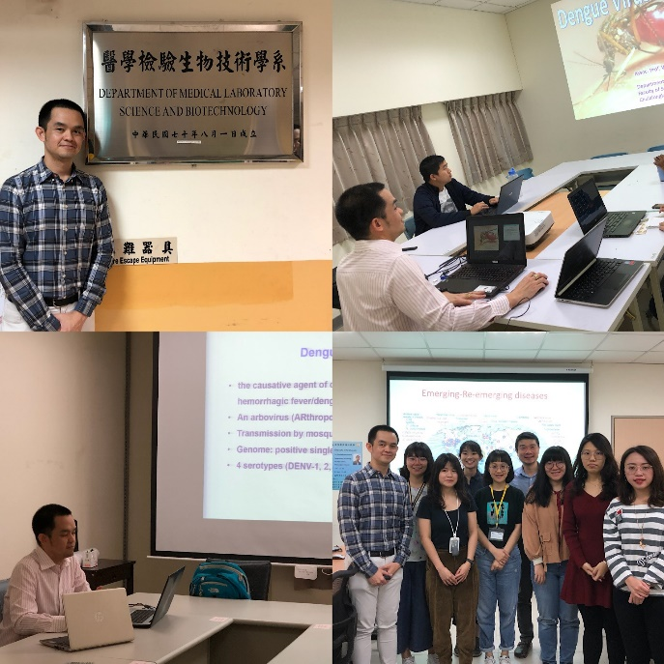

* 2019.12.16-12.19 The department of public health, Kaohsiung Medical University have been invited Professor Frances Yang, Department of Occupational Therapy School of Health, from Professions University of Kansas Medical Center in USA to speak about “The Latent Variable Modeling Course”.
* 2019.11.01 We invite Professor Goh to share a special talk for graduate students. He is a practice professor of Division of Analytics and Operations in college of management at National University of Singapore. The topic is Global Supply Chains and Digital Transformation in Hospital.
* 2019.10.29-10.31 Professor Maggie Reitz from Towson University, USA, was invited by Dept. of Occupational Therapy to participant the International Scholar Co-teaching Program
* 2019.10.28-10.30  Assistant Professor Karla Ausderau from Wisconsin University, USA, was invited by Dept. of Occupational Therapy to participant the International Scholar Co-teaching Program
* 2019.09.16-09.20 Department of Medical Imaging and Radiological Sciences received distinguished professors from Ibaraki Prefectural University of Health Sciences, and arranged the visiting of teaching facilities and hospitals.
* 2019.09.15-09.22 Associate Professor Megumi Takizawa from Department of PT, IPU Japan, visited Department of PT, KMU, and participated clinical tours and discussion activity in the faculty’s teaching forum.
* 2019.04.19 The department of public health, Kaohsiung Medical University have been invited Associate Professor Hui-Ling Yen, Epidemiological Science, from The University of Hong Kong in Hong Kong to speak about “Influenza viruses in the air: in experimental and field setting”.
* 2019.04.15 Dr. Jo-Chi Jao, chairman of Department of Medical Imaging and Radiological Sciences, invited Prof. Kwan-Hoong Ng for a speech. The title of the speech is Global Medical Physics Education.
* 2019.03.04-03.08 Dr. Arunee Thitithanyanont from Mahidol University, Thailand has been invited by Dr. Sheng-Fan Wang, from Department of Medical Laboratory Science and Biotechnology, Kaohsiung Medical University, Taiwan to attend Kaohsiung Medical University to participate in international scholar co-teaching as well as discussing the dual degree program.
* 2019.03.04-03.06 Department of Physical Therapy, SF Hsiao invited Dr Hiroki Mani and Dr Yasuyuki Takamatsu from Hokkaido University Japan gave a speech for the ‘Development of postural control’ and ‘Neural plasticity & neuromodulation’ in the Department of Physical Therapy.

**2018**

* + 2018.12.14-12.23 The international exchange and collaborate with Dr. Thomas Wan from University of Central Florida.（HAMI）
  + 2018.12.07-12.12 The international exchange and collaborate with Dr. Christian Wernz from Virginia Commonwealth University.（HAMI）
  + 2018.11.05-11.23 Dr. Daniel Bender from Institute of Biochemistry, University of Cologne, Germany visited Medical Laboratory Science and Biotechnology, KMU for research and laboratory collaboration. On Nov 19, 2018, Dr. Bender gave a talk on “Sulfite oxidase in human health and disease”.
  + 2018.10.19 Department of Physical Therapy, SF Hsiao invited Prof. Yu Konishi from Department of Physical Education, National Defense Academy gave a speech for the neurophysiological mechanism of ACL injury.
  + 2018.09.16-09.23 Department of Medical Imaging and Radiological Sciences,Department of Physical Therapy and Department of Occupational Therapy received distinguished professors from Ibaraki Prefectural University of Health Sciences, and arranged the visiting of teaching facilities and hospitals
  + 2018.09.03 Representatives from Okayama University, Japan visited Kaohsiung Medical University to introduce the Academic Exchange Program. Prof. Shinya Saito (Vice Dean) and Prof. Takehito Taguchi also welcomed KMU graduate students to join this International Program. Two departments of College of Health Sciences (including Department of Laboratory Sciences and Biotechnology and Department Radical Imaging and Radiological Sciences) and Division of R&D and International Affair of College of Health Sciences were invited to participate this activity.  
    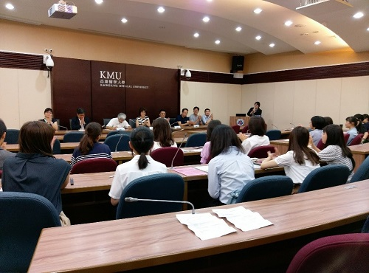 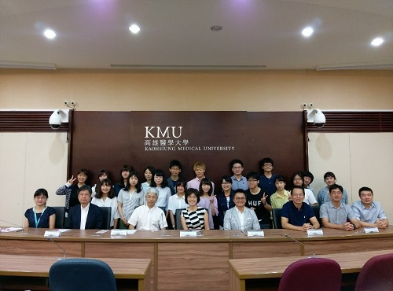
  + 2018.08.16  Associate Professor Liang-Yin Ke invited Professor Etsuro Ito to give a talk in KMU and to discuss research project. The talk entitled as “Urinary adiponectin as a new diagnostic index for chronic kidney disease due to diabetic nephropathy
  + 2018.07.07 The CEO of World Confederation for Physical Therapy (WCPT), Jonathon Kruger, was invited to give a workshop on advocacy in KMU. The workshop was funded by the Taiwan Physical Therapy Association (TPTA) and the Department of NGO International Affairs, Ministry of Foreign Affairs. Two Vice Presidents from Korean Physical Therapy Association were also attended the workshop.
  + 2018.04.30-05.03 Professor Hiroshi Maejima from Faculty of Health Sciences, Hokkaido University, Japan, gave series of lectures to undergraduate and postgraduate students of Department of Physical Therapy.

